Pre-Requisites and steps to run ZeroZillaCrudApplication

* Overview
  1. As mentioned in task description, I have created a Crud Application with Spring boot and Spring data JPA to interact with database. Other than that, I have implemented token-based authentication using Spring JWT token and some basic validations of spring security.
  2. To validate the request, we need to provide a token in each and every request to the endpoint in order to authorize the request.
  3. There is an expiration to this token so if we get regular failure even after providing the token then we need to request for new token and provide the updated token in request.
* Pre-Requisites
  1. Go to git repository- <https://github.com/KushagrSharma/zerozillacrud> and clone the project into local directory.
  2. Import the project as existing maven project into the IDE.
  3. Before running the application we need to update the application.properties file with db name present.
  4. We need to provide appropriate db connection properties and save the changes.
* Steps to Run the application
  1. Run Application
     + In order to run application we need to run the SpringBootJwtApplication.java class as spring boot application
     + As we are using Spring JPA for the db related operations and after valid db connection related properties are provided in application.properties file automatically AGENT and CLIENT tables will be created in configured table with appropriate fields.
  2. As we are using spring JPA for token-based authentication first we need to generate the token hitting the generate token URL using below url in postman.
* URL :- <http://localhost:8080/authenticate>
* Below is the request body we need to pass

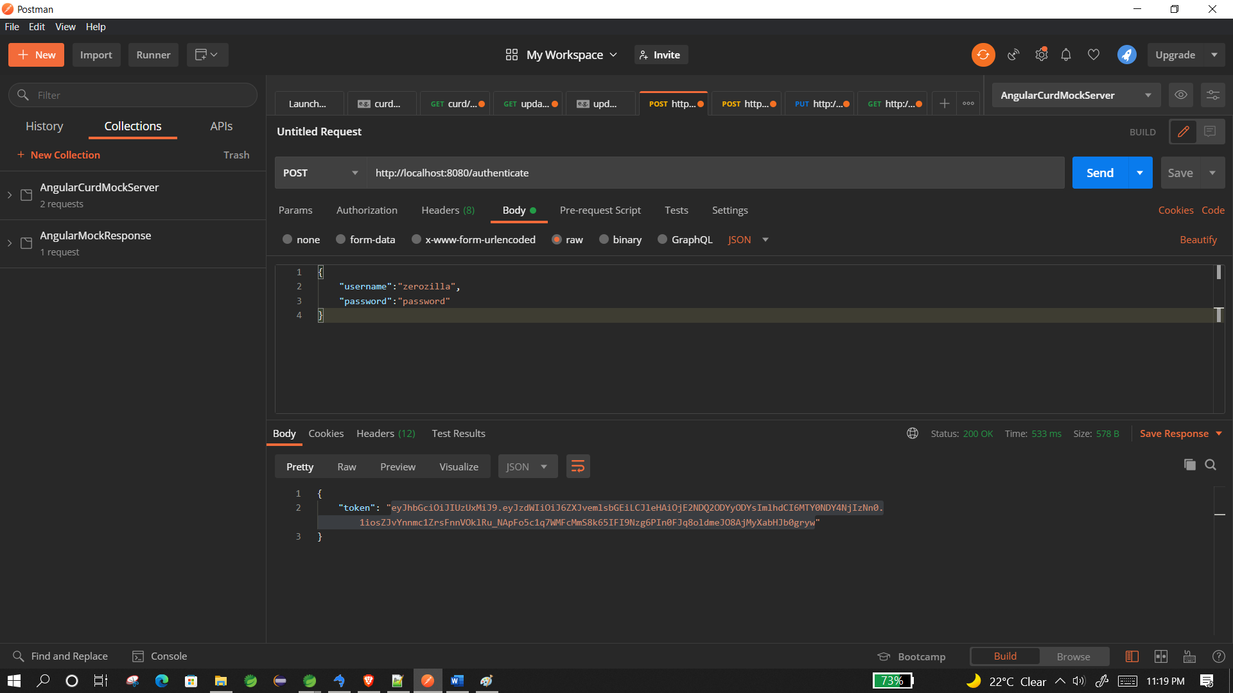

* As seen above once the url is hit a token is generated in response and we need to use this token for further api calls

3. No we will create a Agency and client and an independent agency

* Before hitting api we need to provide authentication token in request as

1. 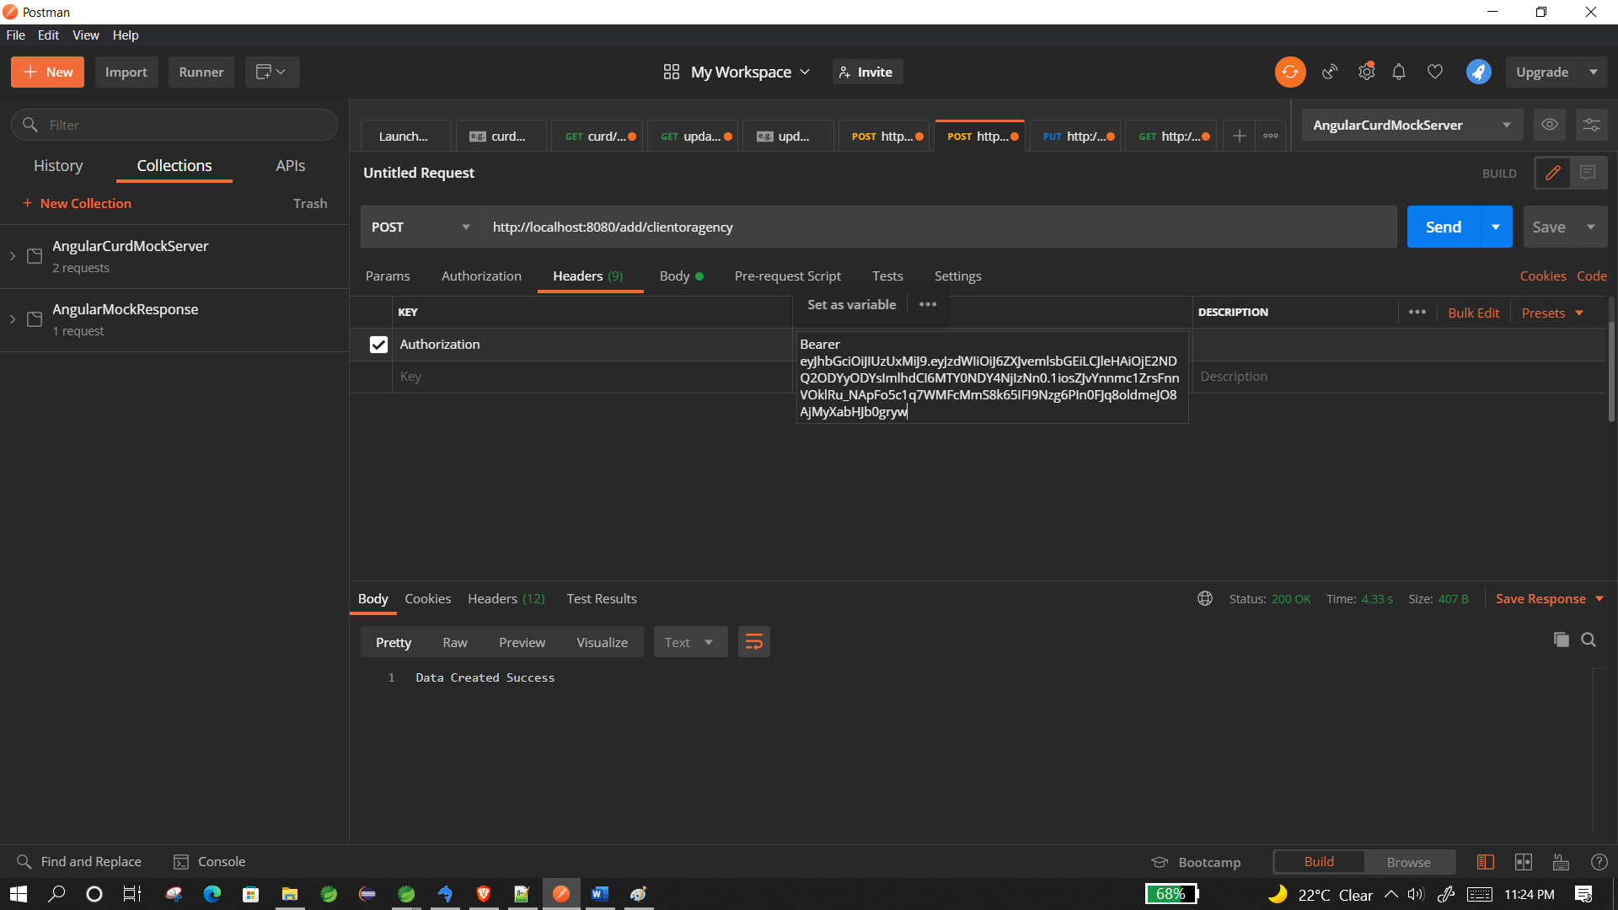
2. We need to provide below details to create an agent and client together in single api call with a POST request

{

    "agencyName":"agent2",

    "address1":"address1",

    "address2":"address2",

    "state":"state",

    "city":"city",

    "phoneNumber":"123456789",

    "clientName":"client1",

    "clientEmail":"test@gmail.com",

    "clinetPhone":"222222222",

    "totalBill":"123"

}

2.1) To Create just an client associate with an agency we need to provide following request

* We need to provide an agencyId in request additionally so that system knows with which agent we need to map the client

{

    "agencyId":"2",

    "agencyName":"agent2",

    "address1":"address1",

    "address2":"address2",

    "state":"state",

    "city":"city",

    "phoneNumber":"123456789",

    "clientName":"client1",

    "clientEmail":"test@gmail.com",

    "clinetPhone":"222222222",

    "totalBill":"123"

}

3) to update client details we need to hit below url

<http://localhost:8080/api/upadteClient/”client> _id” with authentication token from authentication endpoint with below structure.

{

    "agencyId":"2",

    "clientName":"client1",

    "clientEmail":"test@gmail.com",

    "clientPhone":"222222222",

    "totalBill":"123"

}

3. To get the max total count we need to hit below url with authentication token in postman request and API will return appropriate result in request.

* http://localhost:8080/api/getMaxClient